# Question 2

a)

i)

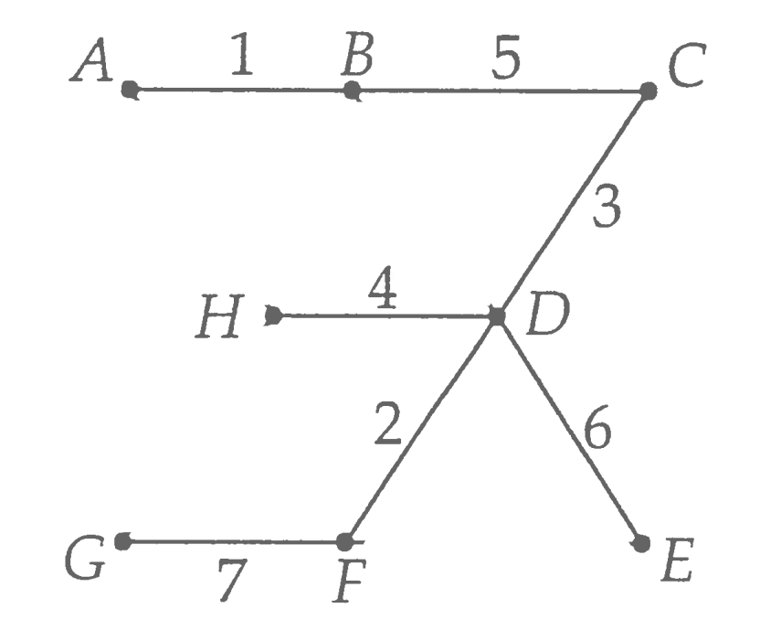

Order of nodes added to tree: A, B, C, D, F, H, E, G

(Could also choose other start node)

ii) Yes, the MST in part i) is unique.

Any MST has 8 - 1 = 7 arcs. The available arcs weights are 1,2,3,4,5,6,7,7,8,8,10.

The 7 smallest arc weights are 1,2,3,4,5,6,7 which are used in i). Apart from 7 they only occur once in the tree. If we swap the arc from G to F with weight 7 in the MST in i) for the arc with weight 7 from F to E, G is no longer connected to the tree.

Therefore any other tree than the one in i) is either not a spanning tree or not minimal.

b)

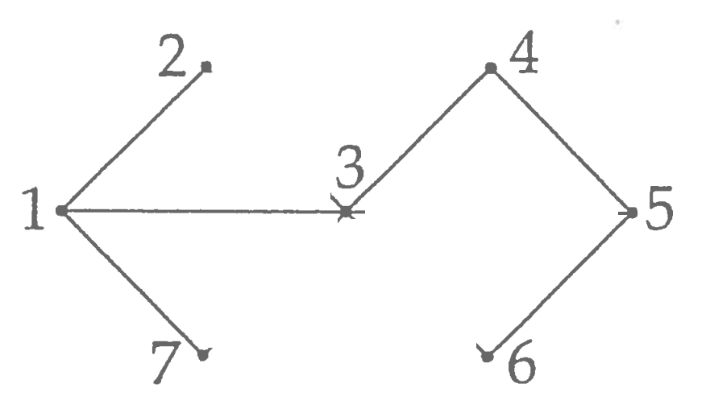

The order in which the nodes are visited: 3, 1, 2, 7, 4, 5, 6

c)

i) 3.

ii)

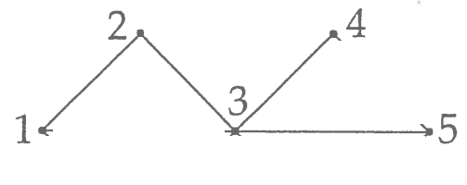

Nodes 2 and 3 are articulation points.

iii)

Assume y is leaf node in T

Assume y is degree 1

Removing degree 1 node doesn’t produce disconnected graph so y not an articulation point Assume y is degree >= 2 (not degree 1)

Assume y is articulation point

Then removing y creates disconnected graph

So when DFS run, y is not a leaf node as there are unvisited nodes beyond y

Contradiction with first assumption, So y is not an articulation point by contradiction

Hence y is not an articulation point by law of excluded middle

Hence if y is a leaf node then y is not an articulation point

Guys I think the key point that we’ve missed so far is that the tree T was generated via DFS. This is really important because it means that y can only be a leaf if the DFS algorithm couldn’t progress any further, i.e., for all child nodes of y, they either do not exist or have already been visited. Therefore, y cannot be an articulation point in G because it either has no child nodes at all, in which case it can’t disconnect the graph, or every node that it has connected to has already been visited by the DFS algorithm and hence there is another path to reach these nodes, so y still doesn’t disconnect the graph. Let me know if I’ve missed something but this seems to make sense to me. -- Brandon Forbes

guys this is a bloodbath

Let them burn

:((((**If you’re here to try and understand the solution then im so sorry**

**Hannah’s Solutions**

Previous version:

Assume for a contradiction that y is a leaf node of T and an articulation point of G.

Removing y and its arcs from G splits G into the disconnected components G1, G2, … (at least 2). We take two arbitrary disconnected components of G1 and G2 of G (wlog). There must be at least node x1 in G1 and a node x2 in G2. As G1 and G2 are disconnected components of G after removing y, x1, x2 and y are 3 distinct nodes.

As T is a spanning tree of G, T contains x1 and x2. Also, T is connected and h**e**nce there is a path from every node in T to every other node in T. So there is a path p from x1 to x2 in T. If the path contains y and its single arc to its parent, then it must enter and exit y along that arc as p does not start or end at y and y only has one arc in T. Hence, we can remove any such loops containing y and its arc from p.

Therefore, T contains a path from x1 to x2 excluding y.

As T is a spanning tree of G it is also a subgraph of G and cannot contain any arcs the G does not contain. Therefore there is also a path from x1 to x2 excluding y in G.

But then G1 and G2 are still connected after removing y and all of its arcs from G.

As G1 and G2 were arbitrary, this is a contradicts the assumption.

Hence, a leaf node y of T is cannot be an articulation point of G.

New Version:

Let G’ be the subgraph obtained from G by removing y and its only arc.

To show: y is not an articulation point of G i.e. G’ is a connected graph.

There is a path from any node in T to any other node in T, as T is a spanning tree.

Claim: There is a path from any node != y in T to any other node != y in T not containing y as an intermediate node.

Proof of claim: If the path contains y, it exits and enters y along the same arc from y to its only parent, so we can remove this loop. Remove loops until the path does not contain y.

Hence, after removing y and its only arc from T to obtain a subgraph T’, there is a path from any node in T’ to any other node in T’ i.e. T’ is connected. As T is a subgraph of G, T’ is a subgraph of G. By construction, T’ contains all nodes of G apart from y and doesn’t contain any of y’s arcs. Therefore, T’ is a connected subgraph of G’ containing all of G’s nodes. Hence, G’ is connected.

**--- Joon’s musings ---**

**- Wise**

**- 10/10 wuld listen to his musings**

“There is a path from any node to any other node in T without y (since y is a leaf).

T is a subgraph of G, so this path also exists in G.” @hannah comments pls (:

**----------------------------**

Don’t know what this is:

*Assume for a contradiction that y is a leaf node of T and an articulation point of G.*

*Remove any such loops containing y and its arc from p.*

*Therefore, T contains a path from x1 to x2 excluding y.*

*As T is a spanning tree of G it g y and its arcs from G splits G into the disconnected components G1, G2, … (at least 2). We take two arbitrary disconnected components of G1 and G2 of G (wlog). There must be at least node x1 in G1 and a node x2 in G2. As G1 and G2 are disconnected components of G after removing y, x1, x2 and y are 3 distinct nodes.*

*As T is a spanning tree of G, T contains x1 and x2. Also, T is connected and hence there is a path from every node in T to every other node in T. So there is a path p from x1 to x2 in T. If the path contains y and its single arc to its parent, then it must enter and exit y along that arc as p does not start or end at y and y only has one arc in T. Hence, we can remois also a subgraph of G and cannot contain any arcs the G does contain. Therefore there is also a path from x1 to x2 excluding y in G.*

*But then G1 and G2 are still connected after removing y and all of its arcs from G.*

*As G1 and G2 were arbitrary, this is a contradicts the assumption.*

*Hence, a leaf node y of T is cannot be an articulation point of G.*

**Anindita’s Solution**

* **Weak af**
* **Don’t rate**

Alternative answer (please delete if wrong):

If n is a leaf in in T, then n is either:

* A leaf in G (has degree 1 in G)
* Part of a cycle in Gn

If n has degree 1 in G, then it is clear to see that it is not an articulation point in G.

If n is part of a cycle, then, say, it is connected to nodes x and y such that there is a path from x to y through the intermediary node n, and also a path from x to y without the node n. Thus by removing n and its subsequent arcs, the path from x to y without n still exists, thus the graph is not disconnected.

Therefore if n is a leaf node in T, then it is not an articulation point in G.

-----

Some other useful observations:

1. If y is a leaf node in tree T, then every node that y connects to in G is an ancestor of y in T
2. y is an articulation point of G iff y has two neighbouring nodes in G such that if y were to be removed, there would be no path between those two nodes any more
3. From (1), removing y would not remove any unique paths between its neighbours since all of its neighbours in G are its ancestors in T. So to get between any neighbours, we just follow the path down from the root that used to lead to y
4. By (3) and (2), y is not an articulation point of G

iv)

“=>”:

Assume for a contradiction that x is an articulation point and has degree < 2. Then x has degree 1 or 0. If x has degree 1 it cannot be an articulation point by (iii)) and if x has degree 0, T and hence G only have one node, so there cannot be any disconnected components after removing x.

Hence, x must have degree ≥ 2 if it is an articulation point.

“<=”:

Assume for a contradiction that x is not an articulation point but has degree ≥ 2. Then there are at least two distinct nodes adjacent to x in T. We take the node that DFS choses first after x to be y and a arbitrary different node adjacent to x in T to be z.

As x is not an articulation point of G, there must still be a path p from y to z in G after removing x and its arcs. But we used DFS starting at x to obtain T from G. We visit y from x first. But then we must visit all the nodes in p including z after visiting y before backtracking all the way to x, as we only backtrack, when there are no more unvisited nodes adjacent to the current node. But then z would already be visited when we reach x again so there would be no arc from x to z in T.

This contradicts our assumption that x has degree ≥ 2, as z was arbitrary. Hence, x must be an articulation point if it has degree ≥ 2.

**“Why are they doing less than or equal to”**

* **Anindita Ghosh**

----  
**I’ll give this a try because why not:**

iii) Call the removed leaf node Y, and the one node that it’s linked to X. We know that Y != X because G is a simple graph (hence no loops).

Since T is a tree, Y and X are both connected to every other node in the graph.

If after removing Y, G is disconnected, it must be due to the removal of an arc incident on Y. But there is only one such arc: the arc YX.

We already know that X is connected to every arc in G through T, and none of those connections were through Y since Y was only directly connected to X.

So all of X’s connections to the other nodes in T must be intact.

Therefore, T is still connected, and since T is a subgraph of G, G must still be connected. So Y is not an articulation point of G.

iv)

To prove X degree ≥ 2 <=> X is articulation point, must prove:  
1) X degree ≥ 2 => X is articulation point

2) X is articulation point => X degree ≥ 2

≡ ¬(X degree ≥ 2) => ¬(X is articulation point) (by contrapositive)

≡ X degree 0 or 1 => X not articulation point

This can easily be proved, see Andy’s answer above.

1. **Is the hard part.**

Assume X has degree ≥ 2:

Then X has two children, Y and Z, Y ≠ X ≠ Z because tree, simple graph.

Since T is a tree, Z and Y are not connected in T except through X (or there would be a cycle)

Since T was formed by DFS, and DFS exhausts the arcs of the children nodes before returning to the arcs of the parent node, Y and Z must not be connected in G except through X.

Therefore deleting X and the arcs incident on X would remove the only connection between Y and Z, making G disconnected. So X is an articulation point.